1453-050

Assignment 1
Introduction to Computers

Due Date: Sept. 18
Email to travisplawicki@gmail.com
Create subject line of email like so: A1:Name, StudentNumber, Course Number
Purpose: To sign up for Office 365. Use OneNote or Microsoft Word to document your work.
- See website http://techsolutions.uwinnipeg.ca/index.php/2013-08-15-21-20-22/office-365-proplus
Signup for Office 365 as instructed in the above link.
Once inside take a screenshot like so via OneNote:
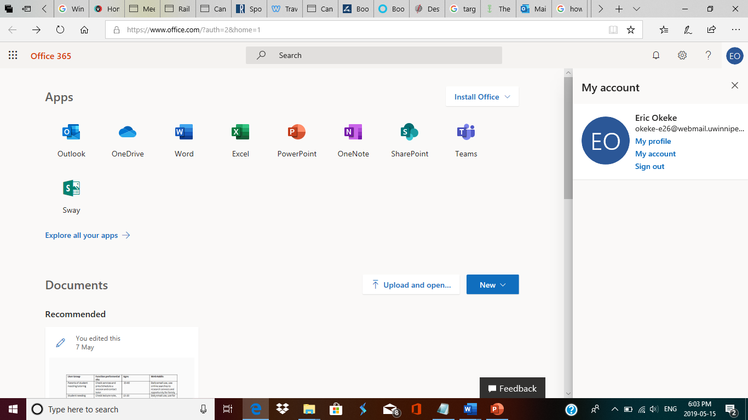

2.) What is Office 365?
3.) List the purpose of each application:
- Word
- Excel
- Outlook
- Access
- PowerPoint
- OneNote
- SharePoint
- One Drive

- Determine and document the following on a computer of your choice. It could be a personal, work or school computer.

  - Amount of RAM
  - CPU
  - What process is consuming the most RAM and CPU at this point in time?
  - Hard drive space
  - Name of domain/workgroup your machine is on.
  - Operating System version.
  - Is it virtual of a physical computer?
  - Determine if Update for Microsoft Office 2013 (KB3039720) 32-Bit Edition is installed.
  - What is Widows Defender?
  - Is the Windows Firewall on?

